**Spring Core and Maven**

**Exercise 1: Configuring a Basic Spring Application**

**Scenario:**

Your company is developing a web application for managing a library. You need to use the Spring Framework to handle the backend operations.

File name: pom.xml

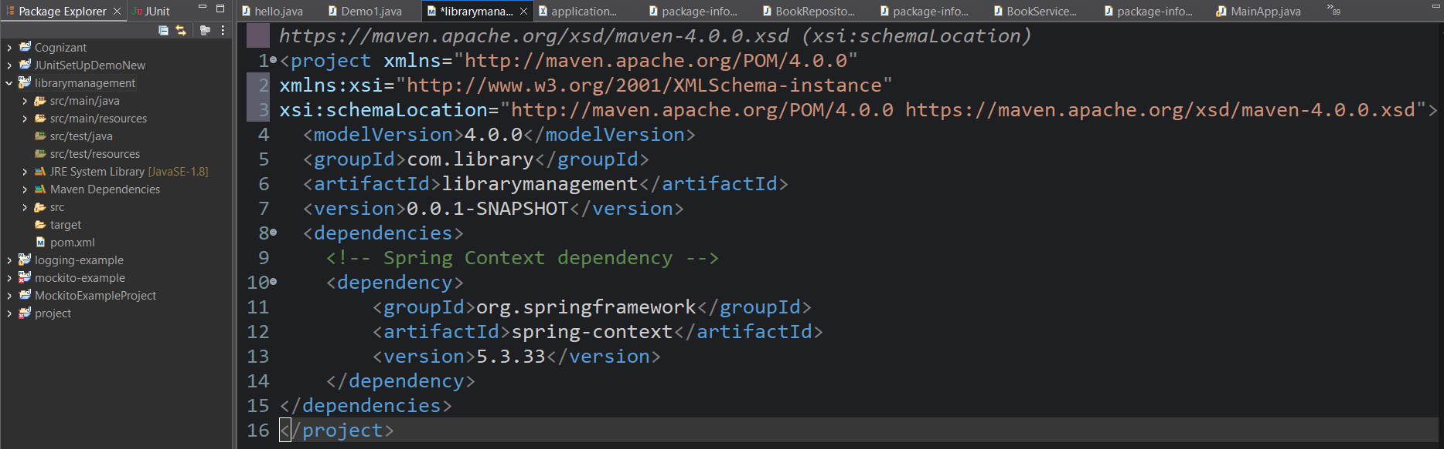

File name: applicationContext.xml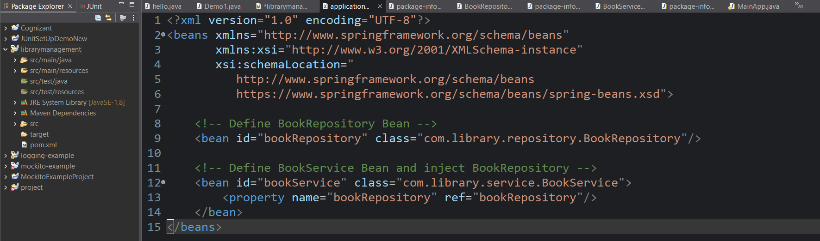

Package name: com.library.repository

Class name: BookRepository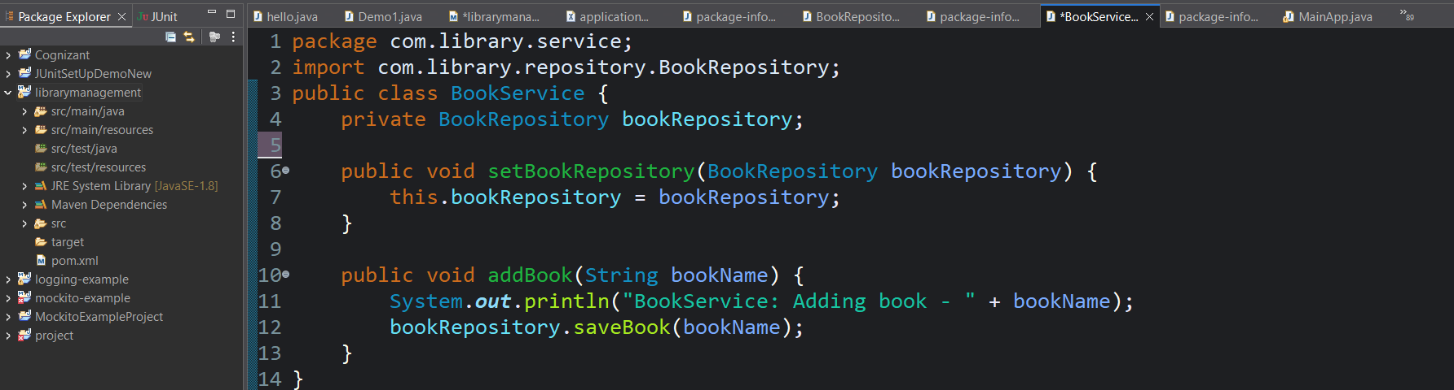

Package name: com.library.service

Class name: BookService 

Package name: com.library

Class name: MainApp

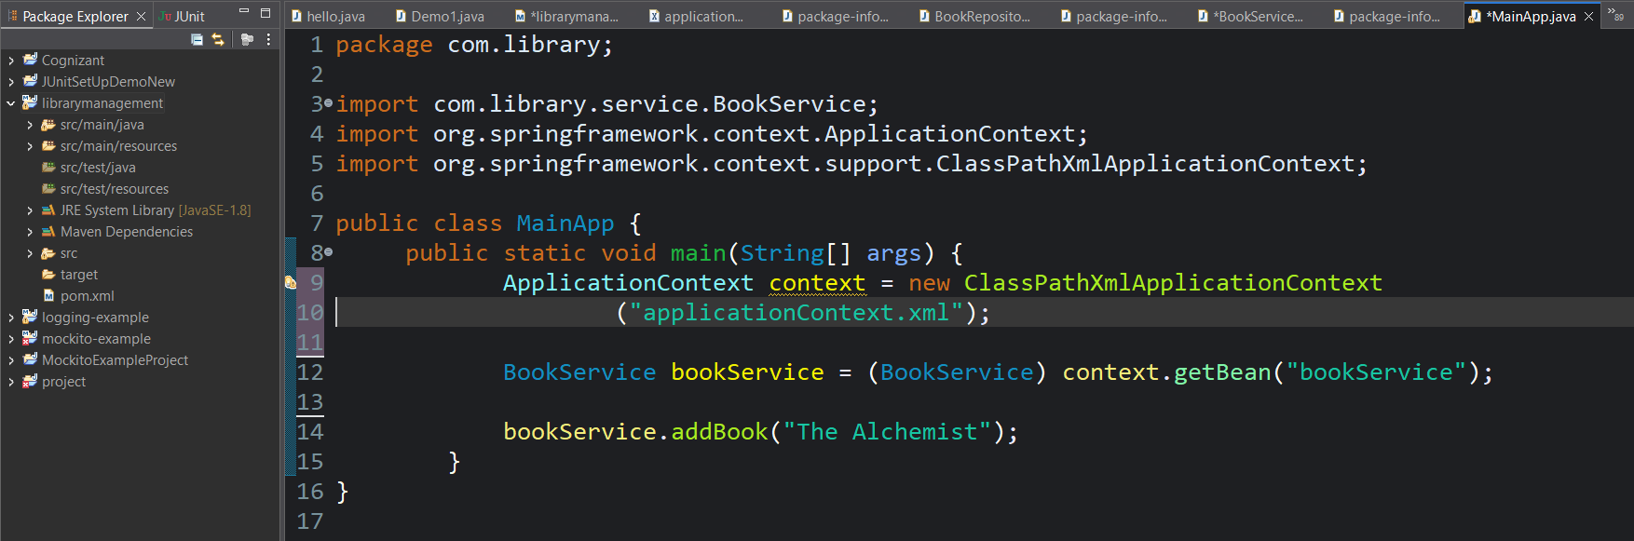

Output:

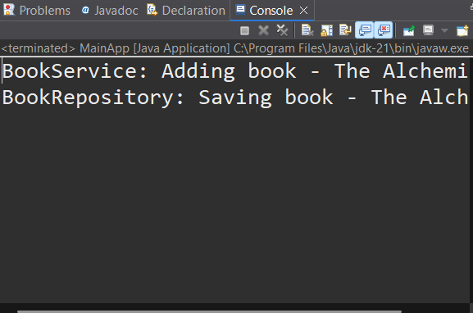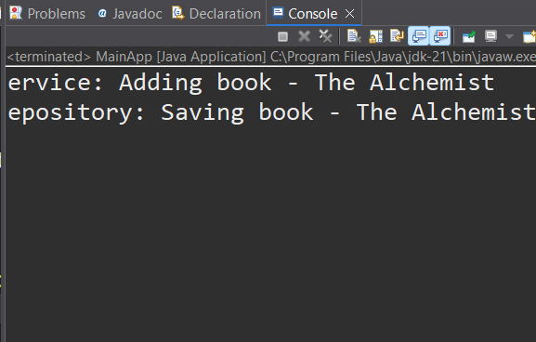

**Exercise 2: Implementing Dependency Injection**

**Scenario:**

In the library management application, you need to manage the dependencies between the BookService and BookRepository classes using Spring's IoC and DI.

File name: pom.xml

File name: applicationContext.xml

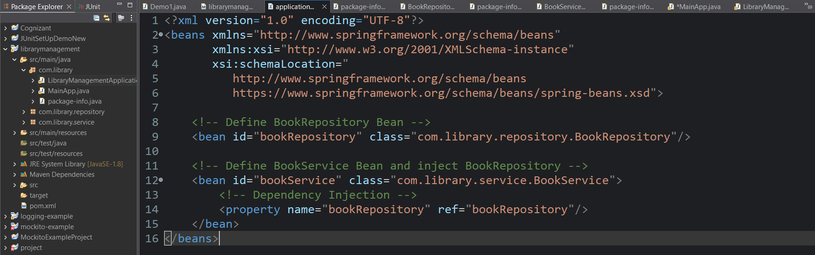

Package name: com.library.repository

Class name: BookRepository 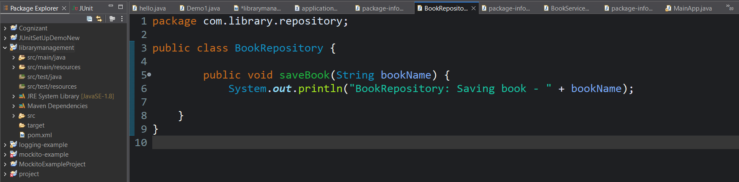

Package name: com.library.service

Class name: BookService 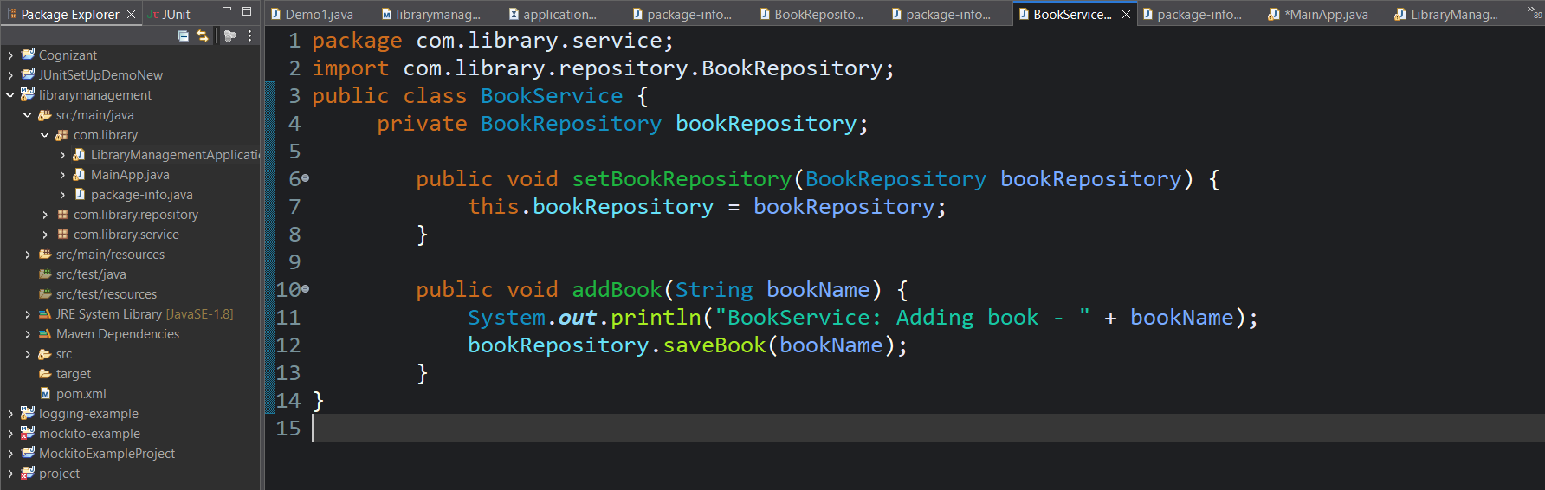

Package name: com.library

Class name: MainApp

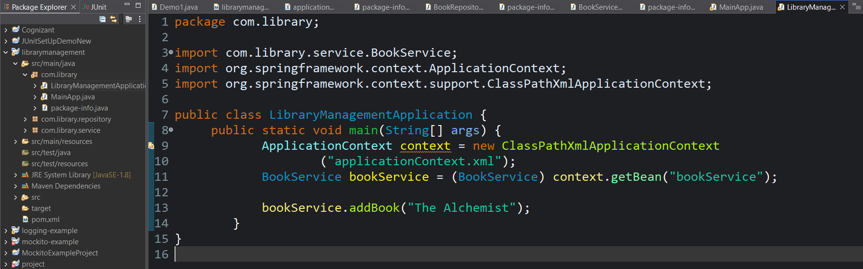

Output:

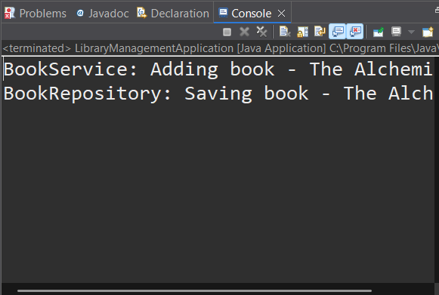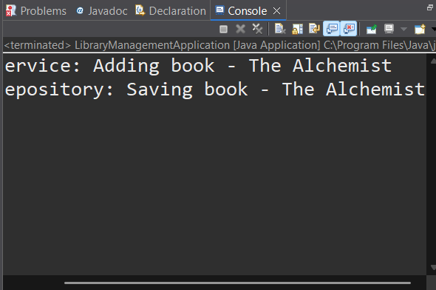**Exercise 4: Creating and Configuring a Maven Project**

**Scenario:**

You need to set up a new Maven project for the library management application and add Spring dependencies.

File name: pom.xml

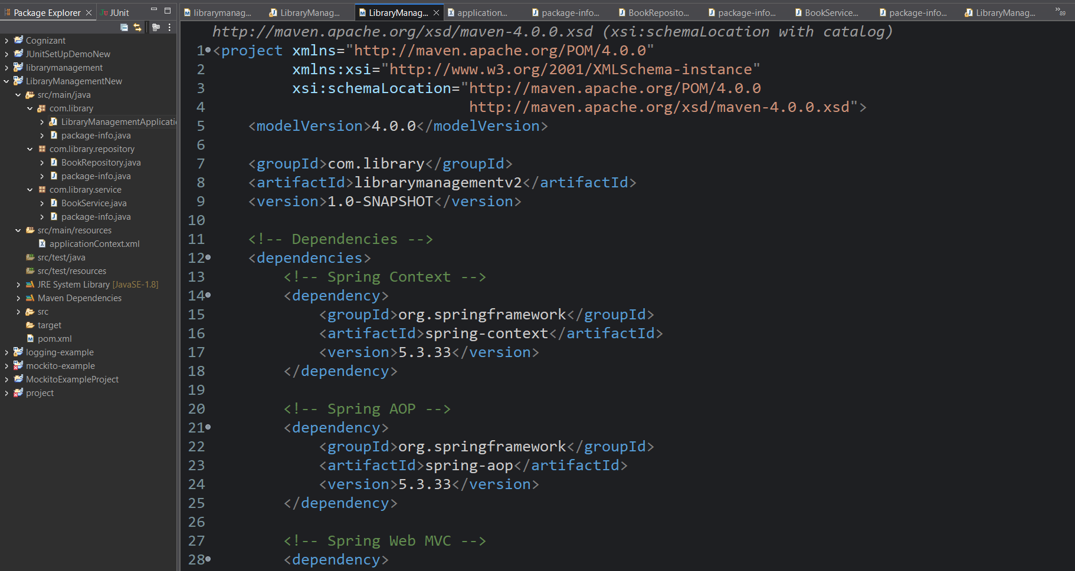 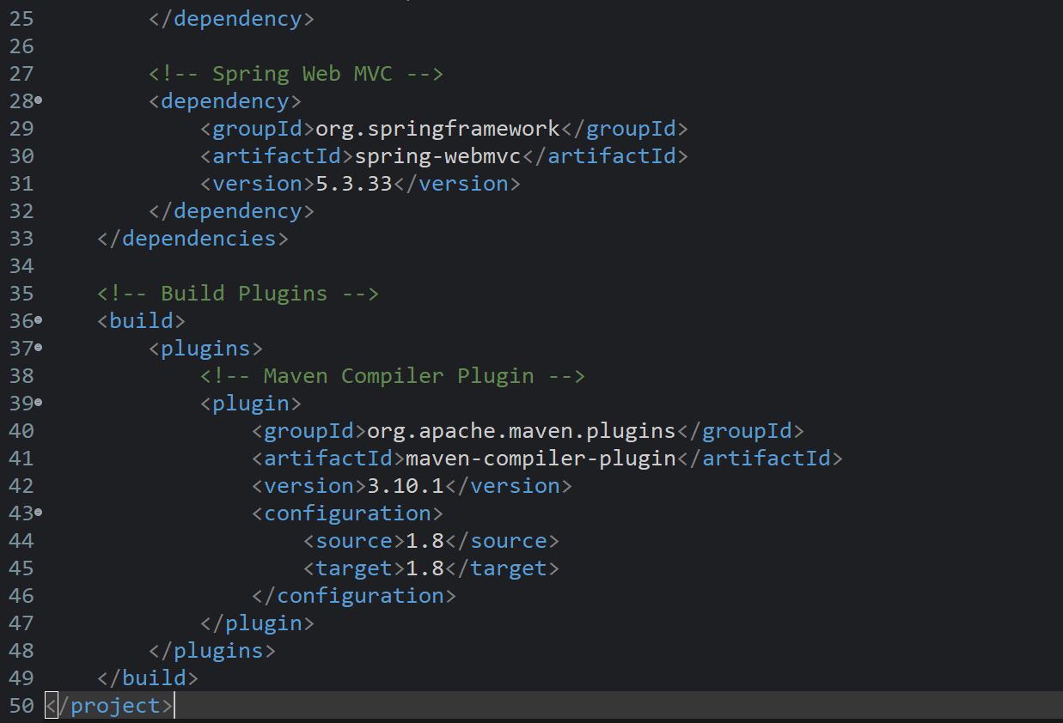

File name: applicationContext.xml

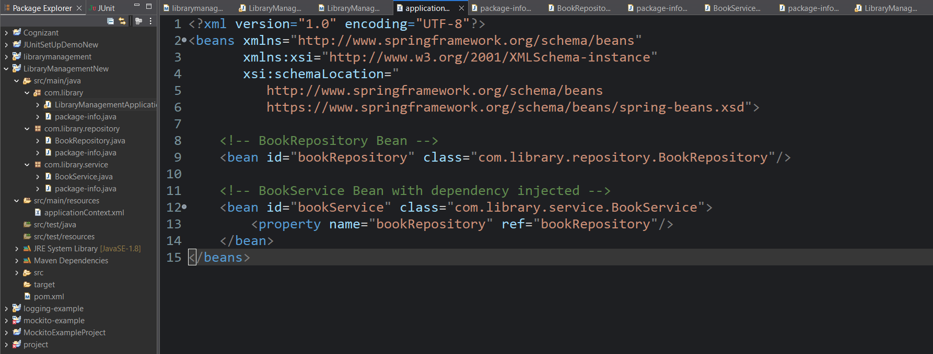

Package name: com.library.repository

Class name: BookRepository

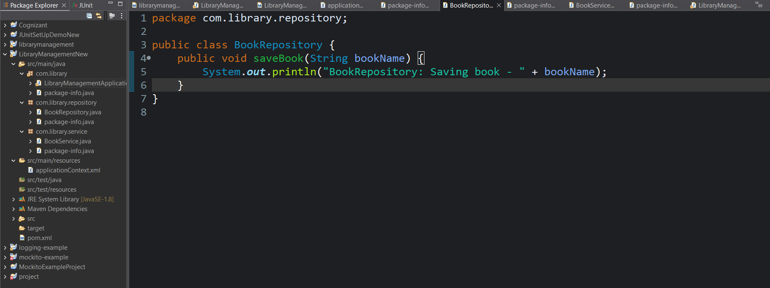

Package name: com.library.service

Class name: BookService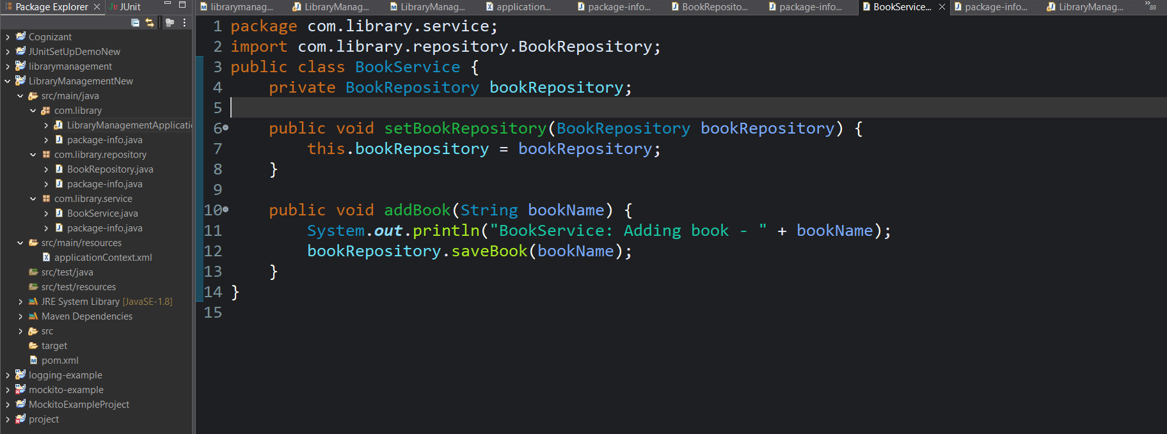

Package name: com.library

Class name:LibraryManagementApplication

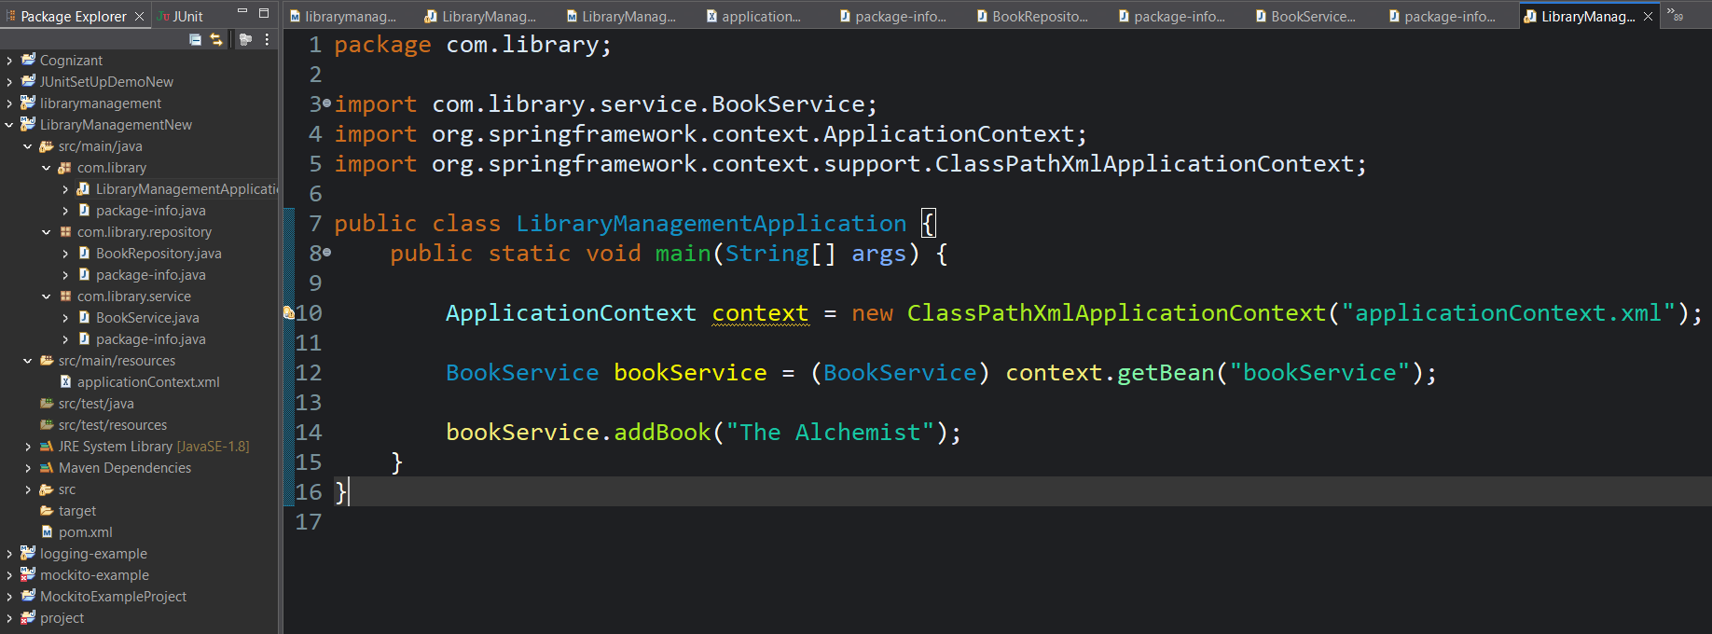

Output:

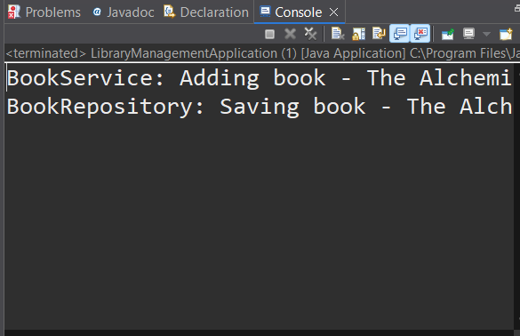 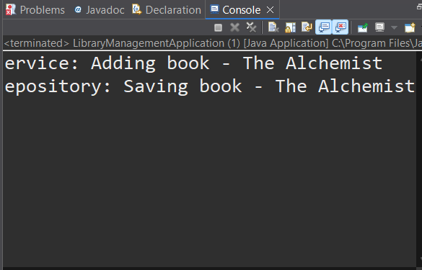

**Exercise 5: Configuring the Spring IoC Container**

**Scenario:**

The library management application requires a central configuration for beans and dependencies.

File name: pom.xml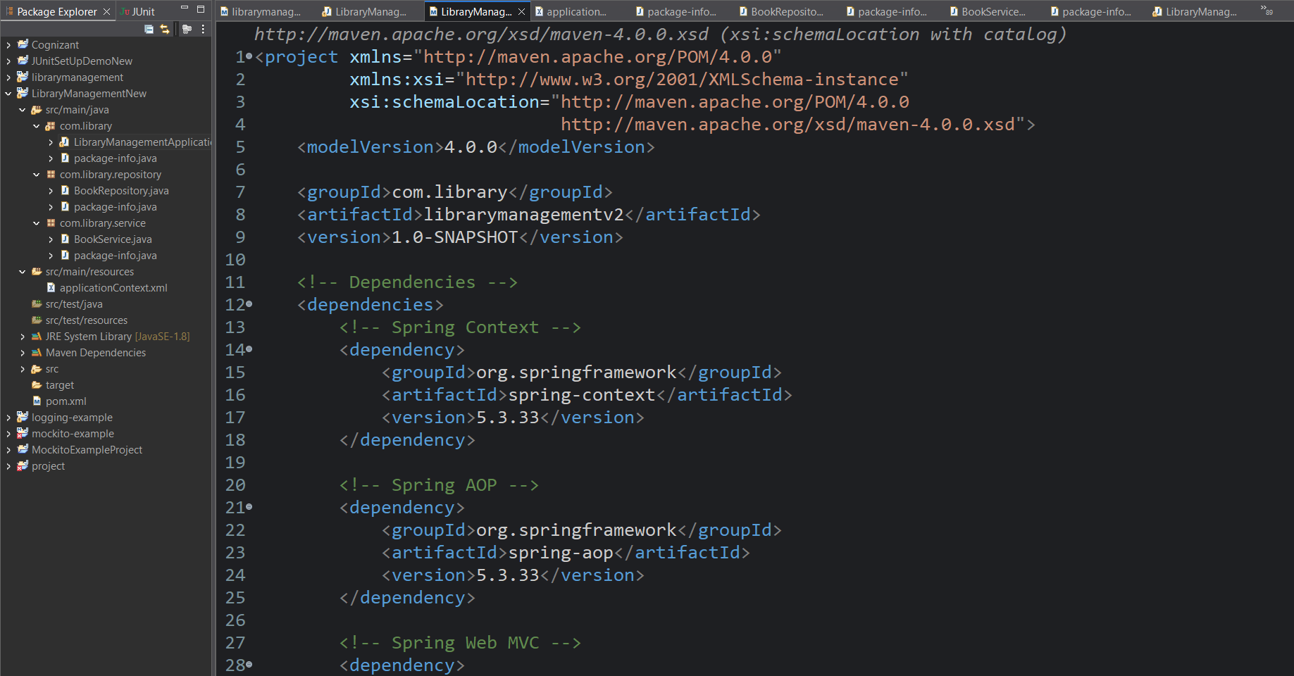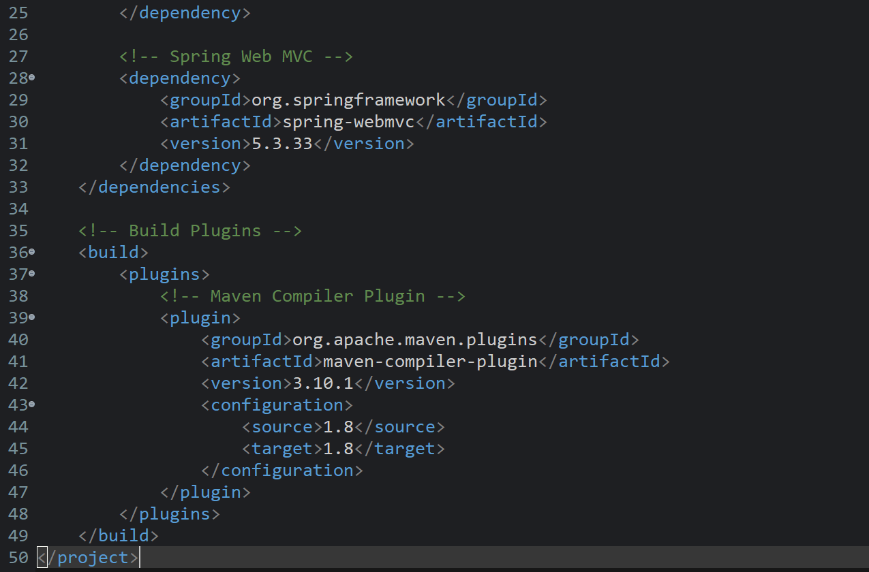

File name: applicationContext.xml

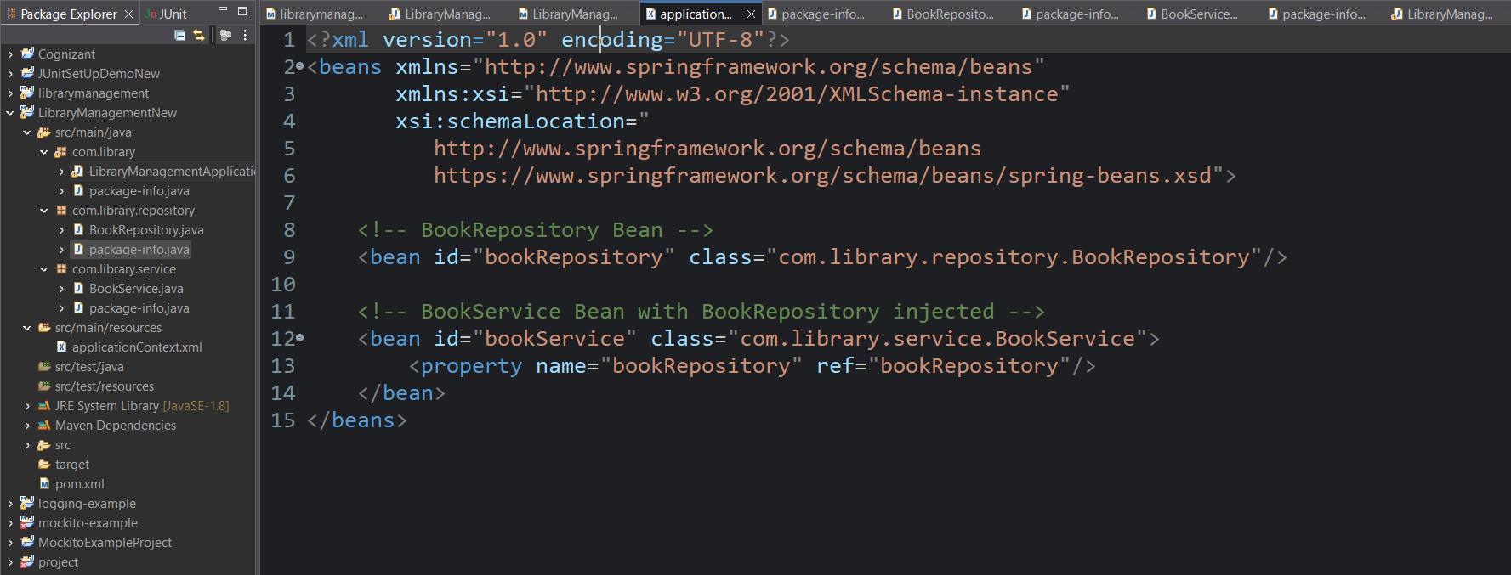

Package name: com.library.repository

Class name: BookRepository

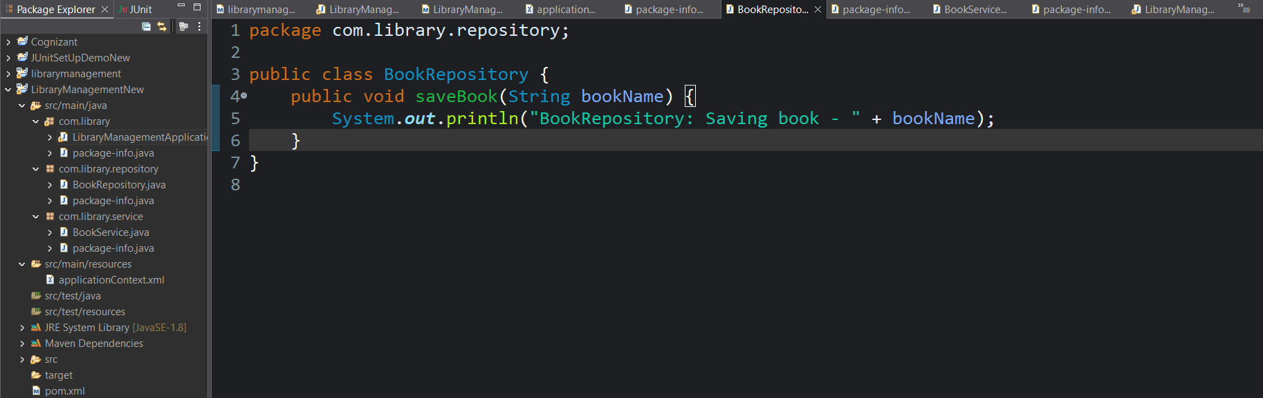

Package name: com.library.service

Class name: BookService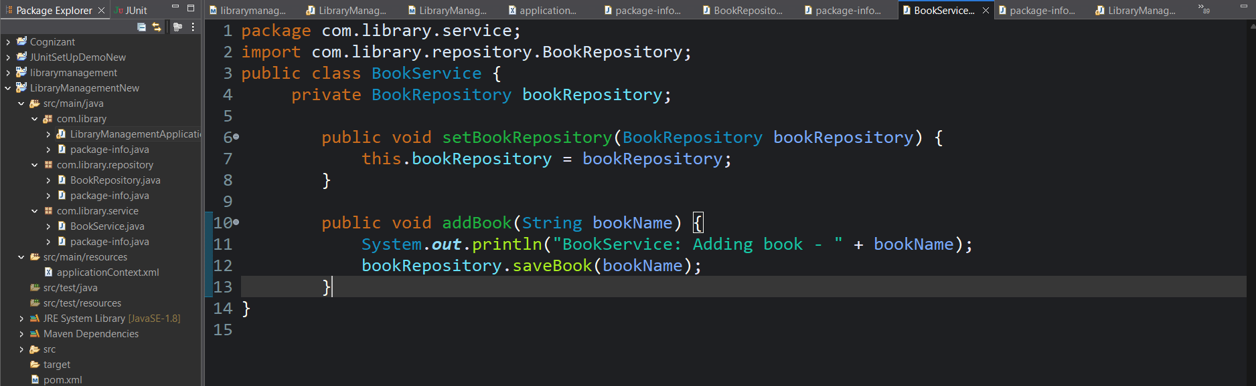

Package name: com.library

Class name:LibraryManagementApplication

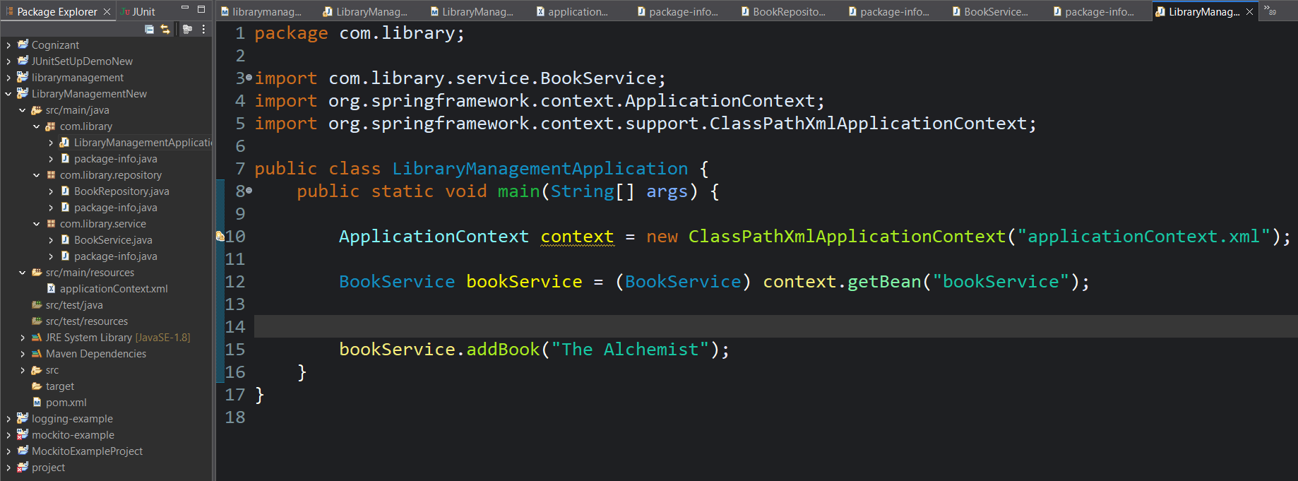

Output:

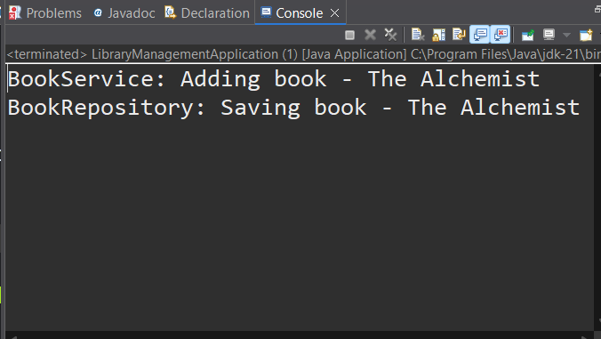

**Exercise 7: Implementing Constructor and Setter Injection**

**Scenario:**

The library management application requires both constructor and setter injection for better control over bean initialization.

File name: pom.xml

 

File name: applicationContext.xml

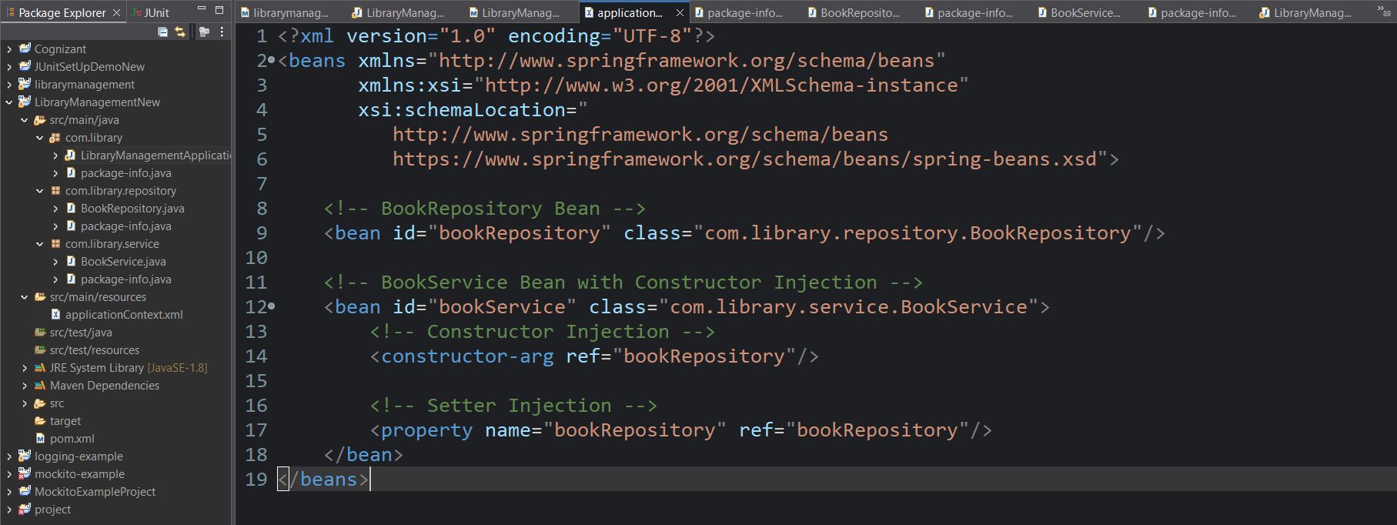

Package name: com.library.repository

Class name: BookRepository

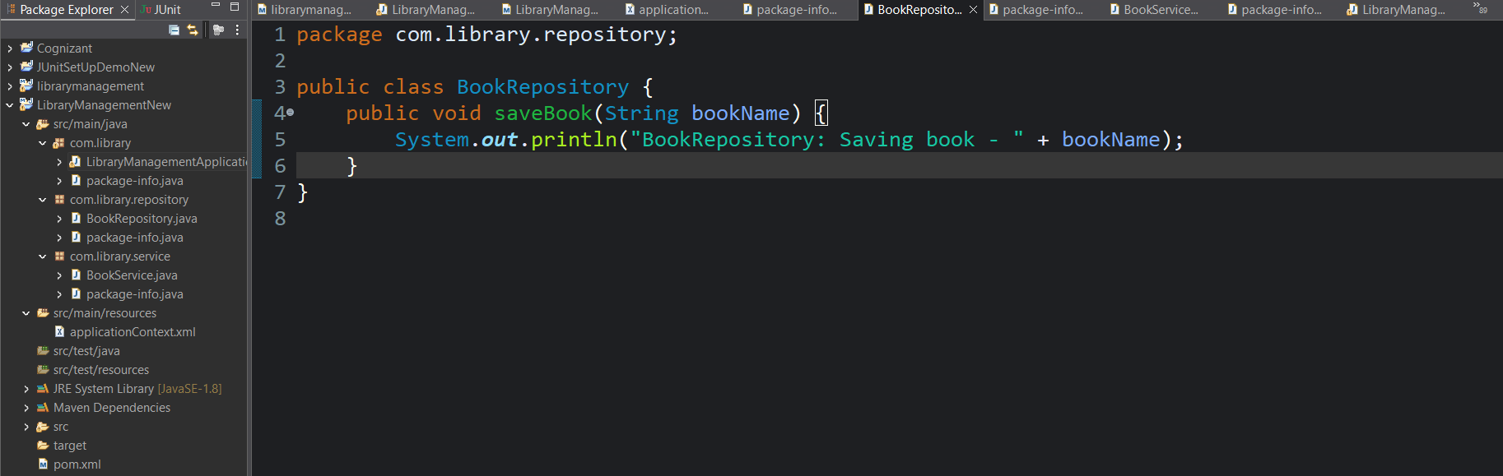

Package name: com.library.service

Class name: BookService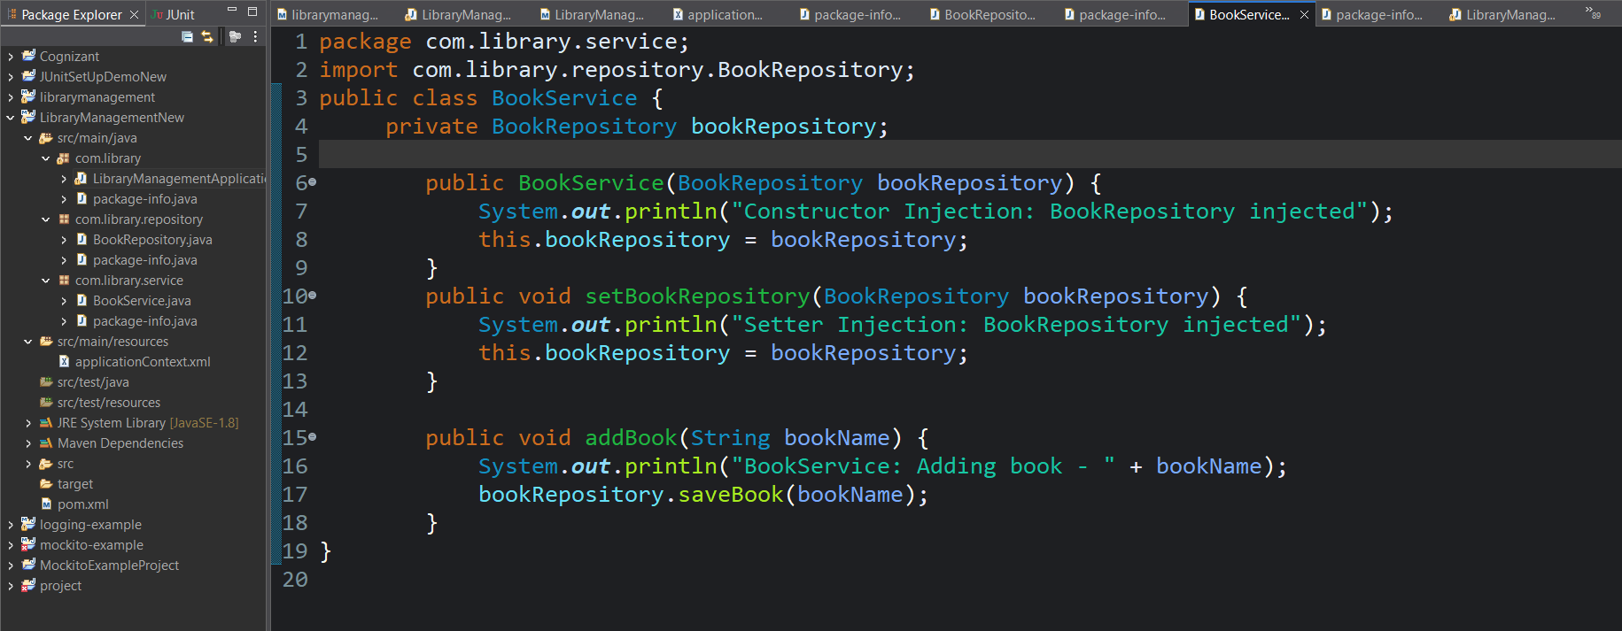

Package name: com.library

Class name:LibraryManagementApplication

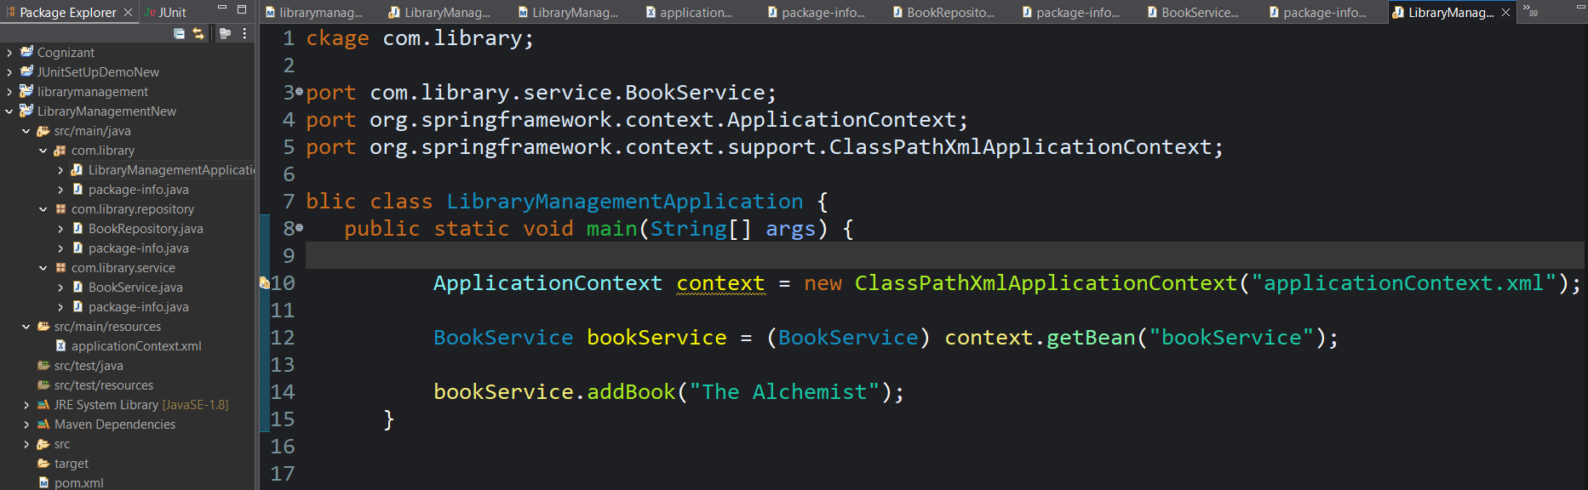

Output: